OPERATION FALSE ASSURANCE

Team Name
Phase Number / Title | Phase 4 - P4-10: SMB to Domain Controller
Incident Date | 2025-10-08 (UTC)
Date Submitted | 2026-08-22

REPORT SCORING
No. | Category | Percentage | Points
1 | Executive Summary | 10% | 100
2 | Incident Timeline & Attack Reconstruction | 15% | 150
3 | Victim & Infrastructure Identification | 10% | 100
4 | Technical Investigation, Evidence & Attack Analysis | 55% | 550
5 | Containment, Eradication & Recovery Recommendations | 5% | 50
6 | Report Quality & Professional Presentation | 5% | 50
 | TOTAL | 100% | 1,000
Evidence Requirement: Major findings must be supported by Security Onion, Kibana, Elasticsearch, Zeek, Suricata, or other authorized evidence. Unsupported findings may receive no more than 50% of the available points for that finding.

1. EXECUTIVE SUMMARY
10% - 100 Points
Summarize the activity observed during this phase. State what happened, the affected system, the nature of the malicious activity, and the operational significance.
On 2025-10-08, compromised workstation 10.11.28.101 was observed establishing repeated authenticated SMB sessions (TCP/445) to internal server 10.11.28.2, identified via Zeek smb_mapping.log as WIN-FGG5B8C1BYF.mytallbeer.com - a Domain Controller for the mytallbeer.com Active Directory domain.
Seven SMB (TCP/445) connections were confirmed between 10.11.28.101 and the Domain Controller, the first observed at 2025-10-08 09:12:36 UTC (an earlier related session on TCP/139 to the same host was logged at 09:00:05 UTC). Six sessions mapped the IPC$ administrative pipe and one session mapped the SYSVOL share.
The same host pair also exchanged a high volume of Active Directory protocol traffic in the surrounding window - DNS, LDAP/LDAP-search, Kerberos, and DCE-RPC (epmapper, netlogon, lsarpc, and 80 drsuapi calls including DRSBind/DRSCrackNames/DRSUnbind) - consistent with directory-service enumeration or replication-protocol activity originating from the workstation.
No IDL_DRSGetNCChanges call (the operation used to pull replicated data/password hashes, e.g. DCSync) was found in the reviewed dce_rpc data, so a confirmed credential-dumping event is not established from this evidence alone.
Operational significance: SMB/administrative-pipe access to a Domain Controller from a workstation, combined with directory-enumeration RPC activity, is consistent with the lateral-movement / interactive-control stage of this intrusion (Operation False Assurance Phase 4) and warrants immediate isolation of 10.11.28.101 and review of authentication logs on the DC.

2. INCIDENT TIMELINE AND ATTACK RECONSTRUCTION
15% - 150 Points
Record the significant events in chronological order. Use UTC for all timestamps.
Date / Time (UTC) | Source | Destination | Protocol / Port | Activity / Observation
2025-10-08 09:00:05 UTC | 10.11.28.101 | 10.11.28.2:139 | SMB / TCP 139 | smb_mapping: \\WIN-FGG5B8C1BYF\IPC$ (PIPE) mapped - first observed SMB-related session to the DC
2025-10-08 09:12:36 UTC | 10.11.28.101 | 10.11.28.2:445 | SMB / TCP 445 | First SMB session on TCP/445 to the DC; IPC$ mapped (source port 49826)
2025-10-08 09:27:36 - 10:12:36 UTC | 10.11.28.101 | 10.11.28.2:445 | SMB / TCP 445 | 4 additional SMB/445 sessions; IPC$ repeatedly mapped (~15 min interval)
2025-10-08 10:21:44 UTC | 10.11.28.101 | 10.11.28.2:445 | SMB / TCP 445 | SMB session maps \\...\sysvol (DISK share) - policy/script volume access
2025-10-08 10:27:36 UTC | 10.11.28.101 | 10.11.28.2:445 | SMB / TCP 445 | 7th and last observed SMB/445 session; IPC$ mapped
2025-10-08 10:37:42 - 10:42:35 UTC | 10.11.28.101 | 10.11.28.2:135/49667 | DCE-RPC (epmapper, drsuapi) | epmapper ept_map lookups followed by drsuapi DRSBind / DRSCrackNames / DRSUnbind calls

Attack Reconstruction
Describe how the activity developed during the phase, what the attacker accomplished, and how the available evidence supports the conclusion.
The workstation's first recorded interaction with the Domain Controller in this window is an SMB/NetBIOS session on TCP/139 at 09:00:05 UTC, followed 7.5 minutes later by the first SMB session on the standard TCP/445 port (09:12:36 UTC) - the connection this finding is scored on.
Over the following ~75 minutes, six more SMB/445 sessions occurred at roughly 15-minute intervals, each mapping the IPC$ administrative named-pipe share used for RPC-over-SMB (DCE-RPC endpoint access), with one session additionally mapping the SYSVOL DISK share.
In the same window, LDAP/LDAP-search, Kerberos and DCE-RPC traffic (epmapper, netlogon, lsarpc, and 80 drsuapi calls) was exchanged between the same two hosts, culminating in repeated DRSBind / DRSCrackNames / DRSUnbind sequences at 10:37:42 and 10:42:35 UTC.
This pattern - authenticated SMB/IPC$ access paired with directory-replication-service (drsuapi) RPC calls - is consistent with AD reconnaissance/enumeration tooling (e.g. BloodHound-style collectors or similar) run from the compromised workstation against the DC, rather than routine end-user file access.
No IDL_DRSGetNCChanges call was observed, so full replication/DCSync-style hash extraction is not confirmed; the available evidence supports confirmed lateral SMB access and AD enumeration against the Domain Controller.

3. VICTIM AND INFRASTRUCTURE IDENTIFICATION
10% - 100 Points

Affected System
IP Address | 10.11.28.101
Hostname | Not Determined (not resolvable from network metadata alone)
User Account | Not Determined
Operating System | Not Determined (Windows inferred from SMB/DCE-RPC client behavior)
Active Directory Domain | mytallbeer.com (inferred from target DC's FQDN)
System Role | Workstation, internal segment (10.11.28.0/24)
Status | Confirmed Compromised - actively issuing authenticated SMB and AD directory-service (drsuapi) sessions against the Domain Controller
Status: Confirmed Compromised / Suspected Compromised / Targeted / Scanned / Not Determined

Relevant Infrastructure
Type | Domain / IP Address | Port | Purpose / Observation
Domain Controller | 10.11.28.2 (WIN-FGG5B8C1BYF.mytallbeer.com) | 445 / 389 / 88 / 135 / 49667 | Target of SMB (IPC$, SYSVOL), LDAP, Kerberos and DCE-RPC (drsuapi) sessions from the compromised workstation
Victim Workstation | 10.11.28.101 | ephemeral (49794-50134) | Source of all SMB / LDAP / Kerberos / DCE-RPC sessions toward the DC

4. TECHNICAL INVESTIGATION, EVIDENCE AND ATTACK ANALYSIS
55% - 550 Points
This section contains the main technical findings. Each significant conclusion should be supported by evidence.

4.1 Analyst Findings
No. | Finding / Objective | Answer / Result | Evidence Ref.
1 | Internal server receiving SMB connections | 10.11.28.2 | Figure 2
2 | Destination port / protocol | 445 / TCP | Figure 2
3 | Source (compromised) workstation | 10.11.28.101 | Figure 2
4 | First SMB (445) connection observed (UTC) | 2025-10-08 09:12:36 UTC | Figure 3
5 | Total SMB (445) sessions observed | 7 sessions, 09:12:36 - 10:27:36 UTC | Figure 2
6 | Destination host identity | WIN-FGG5B8C1BYF.mytallbeer.com (Domain Controller, domain mytallbeer.com) | Figure 4
7 | SMB shares accessed | IPC$ (PIPE) x6, SYSVOL (DISK) x1 | Figure 4
8 | CTF Answer | CTK{10.11.28.2|445|2025-10-08 09:12:36 UTC} | Figure 2, 3

4.2 Network Activity
Time (UTC) | Source IP | Destination IP | Port | Protocol | Domain / Host | Observation
2025-10-08 09:12:36.403 UTC | 10.11.28.101 | 10.11.28.2 | 445 | TCP/SMB | WIN-FGG5B8C1BYF.mytallbeer.com | First SMB/445 session; IPC$ mapped (src port 49826)
2025-10-08 09:27:36.436 UTC | 10.11.28.101 | 10.11.28.2 | 445 | TCP/SMB | WIN-FGG5B8C1BYF.mytallbeer.com | IPC$ mapped (src port 49904)
2025-10-08 09:42:36.503 UTC | 10.11.28.101 | 10.11.28.2 | 445 | TCP/SMB | WIN-FGG5B8C1BYF.mytallbeer.com | IPC$ mapped (src port 49922)
2025-10-08 09:57:36.532 UTC | 10.11.28.101 | 10.11.28.2 | 445 | TCP/SMB | WIN-FGG5B8C1BYF.mytallbeer.com | IPC$ mapped (src port 49940)
2025-10-08 10:12:36.508 UTC | 10.11.28.101 | 10.11.28.2 | 445 | TCP/SMB | WIN-FGG5B8C1BYF.mytallbeer.com | IPC$ mapped (src port 49956)
2025-10-08 10:21:44.883 UTC | 10.11.28.101 | 10.11.28.2 | 445 | TCP/SMB | WIN-FGG5B8C1BYF.mytallbeer.com | SYSVOL (DISK) mapped (src port 49983)
2025-10-08 10:27:36.505 UTC | 10.11.28.101 | 10.11.28.2 | 445 | TCP/SMB | WIN-FGG5B8C1BYF.mytallbeer.com | 7th and last SMB/445 session; IPC$ mapped (src port 50006)
Analysis:
All 7 SMB sessions used TCP/445 and were sourced from ephemeral ports (49826-50006) on 10.11.28.101 to 10.11.28.2:445, at fairly regular ~15-minute intervals, indicating a scheduled/automated process rather than interactive manual browsing.
Six of the seven sessions mapped the IPC$ administrative named-pipe share (used to carry DCE-RPC traffic such as drsuapi/lsarpc/netlogon over SMB); one session (10:21:44 UTC) additionally mapped the SYSVOL DISK share, which hosts Group Policy Objects and logon scripts.
A related, earlier SMB/NetBIOS session on TCP/139 to the same destination (IPC$ mapped) was logged at 09:00:05 UTC, outside the TCP/445 scope of this specific finding but confirming the relationship began slightly earlier.

4.3 Lateral Movement
Time (UTC) | Source | Destination | Port / Protocol | Activity
2025-10-08 09:12:36 UTC | 10.11.28.101 | 10.11.28.2 (DC) | 445/TCP SMB | First authenticated SMB session; IPC$ administrative pipe mapped
2025-10-08 09:12-10:27 UTC | 10.11.28.101 | 10.11.28.2 (DC) | 445/TCP SMB | 6 additional IPC$ sessions at ~15-min intervals (7 total)
2025-10-08 10:21:44 UTC | 10.11.28.101 | 10.11.28.2 (DC) | 445/TCP SMB | SYSVOL share (DISK) mapped
2025-10-08 10:37:42-10:42:35 UTC | 10.11.28.101 | 10.11.28.2 (DC) | 135, 49667/TCP DCE-RPC | epmapper ept_map lookups + drsuapi DRSBind/DRSCrackNames/DRSUnbind (AD enumeration)
throughout window | 10.11.28.101 | 10.11.28.2 (DC) | 389, 88, 53 LDAP/Kerberos/DNS | Concurrent LDAP/LDAP-search, Kerberos and DNS activity (285 conn / 204 dns / 92 ldap_search / 53 ldap / 8 kerberos events)
State whether the destination was merely contacted, targeted, or confirmed compromised.
The destination (10.11.28.2, the mytallbeer.com Domain Controller) was contacted with fully-established, authenticated SMB sessions (IPC$/SYSVOL mapped) and DCE-RPC directory-service calls - i.e. more than a mere port scan or unauthenticated probe.
Status: Contacted and session-established (SMB share mapping + drsuapi enumeration confirmed). Whether the workstation obtained interactive command execution or write access on the DC, or exfiltrated replicated AD data, was Not Determined from the available evidence (no IDL_DRSGetNCChanges observed).

4.4 Indicators of Compromise
Indicator | Type | Purpose / Assessment | Recommended Action
10.11.28.2 | IPv4 (internal) | Domain Controller (WIN-FGG5B8C1BYF.mytallbeer.com) - target of SMB/LDAP/Kerberos/DCE-RPC sessions from the compromised workstation | Verify session source against the approved admin workstation list; audit DC SMB and directory-service logging
10.11.28.101 | IPv4 (internal) | Compromised workstation - source of the SMB/AD-enumeration sessions | Isolate host, image for forensics, and hunt for AD-recon/DCSync tooling
WIN-FGG5B8C1BYF.mytallbeer.com | Hostname / FQDN | Identified Domain Controller for domain mytallbeer.com | Cross-reference with asset inventory; confirm DC hardening/tiering controls
drsuapi DRSBind / DRSCrackNames / DRSUnbind (80 calls) | Behavioral indicator (DCE-RPC) | AD directory-replication-service calls from a workstation - atypical for standard user activity | Audit calling account/process; alert specifically on any IDL_DRSGetNCChanges (DCSync) call

4.5 Investigation Evidence
Query / Filter Used:
event.dataset:zeek.conn AND source.ip:10.11.28.101 AND destination.port:445 (Security Onion Hunt)
Finding:
Workstation 10.11.28.101 established 7 authenticated SMB (TCP/445) sessions with internal server 10.11.28.2, first observed 2025-10-08 09:12:36 UTC; smb_mapping.log identifies the server as Domain Controller WIN-FGG5B8C1BYF.mytallbeer.com.

Evidence Reference: Figure 1-5
Kibana / Elasticsearch
Alerts / Suricata: Not Applicable - no Suricata/IDS alert corresponds to this specific SMB session activity; this finding is based on Zeek protocol logs (conn, smb_mapping, dce_rpc) only.
Zeek Logs Used
- conn
- dns
- http
- ssl / tls
- smtp
- files
- dhcp
- kerberos
- smb
- other: smb_mapping, dce_rpc, ldap, ldap_search, kerberos, dns
Relevant observation:
smb.path values (\\WIN-FGG5B8C1BYF.mytallbeer.com\IPC$ and \...\sysvol) tie every SMB/445 session to the same Domain Controller identity; corresponding log.id.uid values allow each smb_mapping record to be pivoted back to its parent zeek.conn session.

4.6 Evidence Register
Evidence No. | Description | Source
E-01 | Security Onion Hunt query event.dataset:zeek.conn AND source.ip:10.11.28.101 AND destination.port:445 - Total Found: 7 | Security Onion
E-02 | Full results table of the 7 SMB (TCP/445) connection events from 10.11.28.101 to 10.11.28.2, sorted by timestamp (UTC) | Security Onion / Zeek conn.log
E-03 | Expanded record of the earliest event confirming @timestamp: 2025-10-08T09:12:36.403Z | Security Onion / Zeek conn.log
E-04 | zeek.smb_mapping records showing smb.path \\WIN-FGG5B8C1BYF.mytallbeer.com\IPC$ and \sysvol, confirming DC hostname/domain and shares accessed | Zeek (smb_mapping.log)
E-05 | zeek.dce_rpc records showing drsuapi (DRSBind/DRSCrackNames/DRSUnbind) and epmapper calls from 10.11.28.101 to the DC | Zeek (dce_rpc.log)
Each screenshot should include a short caption explaining what it shows.

4.7 MITRE ATT&CK Mapping
Tactic | Technique | Technique ID | Evidence
Lateral Movement (TA0008) | Remote Services: SMB/Windows Admin Shares | T1021.002 | 7 SMB sessions (TCP/445) with IPC$/SYSVOL mapping from 10.11.28.101 to DC 10.11.28.2 (Figure 2, 4)
Discovery (TA0007) | Domain Trust Discovery / Account Discovery: Domain Account | T1482 / T1087.002 | 92 ldap_search + 53 ldap events and DRSCrackNames calls against the DC (Figure 5)
Discovery (TA0007) | Network Service Discovery | T1046 | 29 epmapper ept_map (RPC endpoint-mapper) lookups preceding drsuapi/netlogon binds (Figure 5)
Credential Access (TA0006) | OS Credential Dumping: DCSync (precursor activity only) | T1003.006 | 80 drsuapi DRSBind/DRSCrackNames/DRSUnbind calls observed; no IDL_DRSGetNCChanges call identified - full DCSync not confirmed (Figure 5)

5. CONTAINMENT, ERADICATION AND RECOVERY
5% - 50 Points
Provide recommendations based on the findings from this phase.

Immediate Actions
1. Isolate 10.11.28.101 from the network immediately and preserve a forensic image; treat the host as compromised given its direct SMB/AD-enumeration access to the Domain Controller.
2. On the Domain Controller (10.11.28.2 / WIN-FGG5B8C1BYF.mytallbeer.com), review Security event logs (4624/4625/5140/5145) for the account(s) that established the IPC$/SYSVOL sessions and drsuapi calls, and confirm whether the source is an authorized administrator.
3. Force a credential reset for any account confirmed to have authenticated from 10.11.28.101, and review Replicating Directory Changes / Replicating Directory Changes All permissions on the domain to reduce DCSync exposure.

Additional Recommendations
Network:
Restrict SMB (TCP 139/445) and RPC (135, dynamic high ports) access to Domain Controllers to only approved administrative source hosts/jump servers; alert on IPC$/SYSVOL access from non-admin workstations.
Endpoint:
Deploy/verify EDR coverage on 10.11.28.101 and sweep the 10.11.28.0/24 segment for the same behavioral pattern (repeated IPC$ mapping + drsuapi calls) on other hosts.
Accounts / Credentials:
Reset credentials for any account used from 10.11.28.101 against the DC; audit and minimize membership of groups holding Replicating Directory Changes / Replicating Directory Changes All rights.
Active Directory, if applicable:
Enable/verify Advanced Audit Policy for Directory Service Access and Account Management on the DC; adopt tiered administration so standard workstations cannot query drsuapi directly.
Recovery:
Reimage 10.11.28.101 if compromise is confirmed; monitor the DC for renewed IPC$/drsuapi activity from the host post-remediation, and specifically alert on any subsequent IDL_DRSGetNCChanges call.

6. CONCLUSION
Provide the team’s final assessment of the phase. State what happened, what system was affected, what the attacker accomplished, the evidence supporting the conclusion, the impact, and how this phase relates to the larger incident.
Security Onion Hunt data (Zeek conn.log) confirms that compromised workstation 10.11.28.101 established seven authenticated SMB sessions on TCP/445 to internal server 10.11.28.2, the first at 2025-10-08 09:12:36 UTC.
Zeek smb_mapping.log identifies 10.11.28.2 as WIN-FGG5B8C1BYF.mytallbeer.com, a Domain Controller for the mytallbeer.com Active Directory domain, and shows the workstation repeatedly mapping the IPC$ administrative pipe and, once, the SYSVOL share.
Zeek dce_rpc.log further shows the same workstation issuing 80 drsuapi (DRSBind/DRSCrackNames/DRSUnbind) calls alongside LDAP, Kerberos and epmapper traffic against the DC - behavior consistent with Active Directory enumeration/reconnaissance rather than routine file access.
Impact: confirmed lateral network access from a compromised workstation to the organization's Domain Controller, with directory-service enumeration; no confirmed data replication (DCSync) was observed in the reviewed window.
This finding represents the lateral-movement / interactive-control stage of Operation False Assurance Phase 4 and should be correlated with earlier phases documenting how 10.11.28.101 was initially compromised.

7. EVIDENCE LIMITATIONS
List any information that could not be confirmed from the available data. Do not present assumptions as confirmed facts.
The user account(s) and authentication method (NTLM vs Kerberos) used to establish the SMB and drsuapi sessions were not confirmed from the available Zeek metadata alone.
The hostname, operating system, and logged-on user of 10.11.28.101 could not be determined from the reviewed network data.
No IDL_DRSGetNCChanges call was found in the dce_rpc data reviewed; whether any directory data/password hashes were actually replicated (DCSync) is Not Determined.
The specific tool responsible for the drsuapi enumeration pattern (e.g., BloodHound, Mimikatz, native tooling) was not identified; attribution is based on protocol-level behavior only.

8. APPENDICES

Appendix A - Investigation Queries
Query:
event.dataset:zeek.conn AND source.ip:10.11.28.101 AND destination.port:445 (Security Onion Hunt)
Query:
event.dataset:zeek.smb_mapping AND source.ip:10.11.28.101 (Security Onion Hunt)
Query:
event.dataset:zeek.dce_rpc AND source.ip:10.11.28.101 | groupby dce_rpc.endpoint (Security Onion Hunt)

Appendix B - Figures and Screenshots
Use sequential figure numbers. Each figure should include a short caption describing what the evidence demonstrates.
Figure | Caption / Description
Figure 1 | Figure 1 - Security Onion Hunt query event.dataset:zeek.conn AND source.ip:10.11.28.101 AND destination.port:445, Total Found: 7.
Figure 2 | Figure 2 - Full events table of the 7 SMB (TCP/445) connections from 10.11.28.101 to 10.11.28.2, sorted by timestamp (UTC), timezone set to UTC.
Figure 3 | Figure 3 - Expanded earliest event record confirming @timestamp: 2025-10-08T09:12:36.403Z, destination.ip 10.11.28.2, destination.port 445.
Figure 4 | Figure 4 - zeek.smb_mapping records showing smb.path \\WIN-FGG5B8C1BYF.mytallbeer.com\IPC$ and \sysvol - confirms Domain Controller hostname/domain and shares accessed.
Figure 5 | Figure 5 - zeek.dce_rpc records showing drsuapi (DRSBind / DRSCrackNames / DRSUnbind) and epmapper calls from 10.11.28.101 to the Domain Controller.
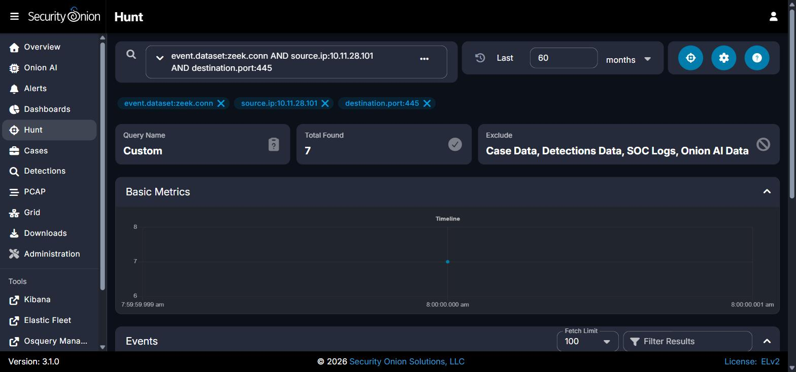
Figure 1 - Security Onion Hunt query event.dataset:zeek.conn AND source.ip:10.11.28.101 AND destination.port:445, Total Found: 7.
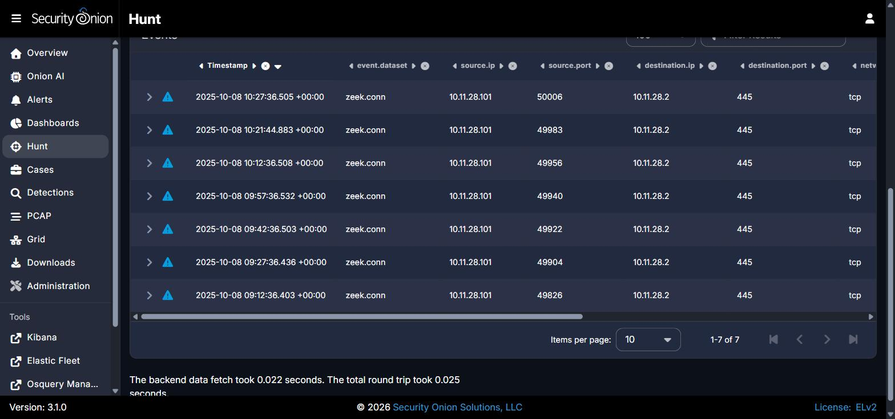
Figure 2 - Full events table of the 7 SMB (TCP/445) connections from 10.11.28.101 to 10.11.28.2, sorted by timestamp (UTC), timezone set to UTC.
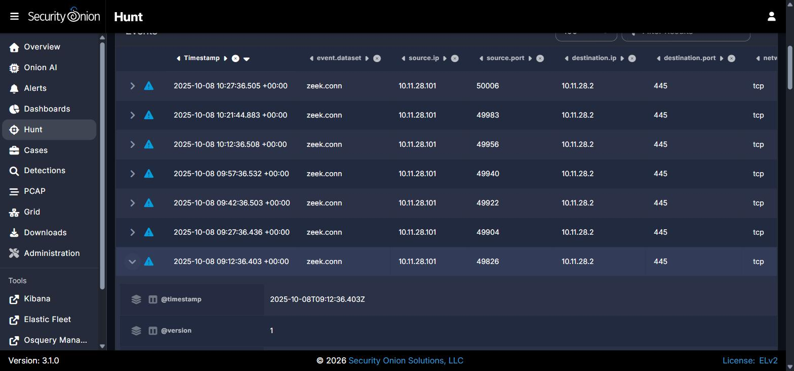
Figure 3 - Expanded earliest event record confirming @timestamp: 2025-10-08T09:12:36.403Z, destination.ip 10.11.28.2, destination.port 445.
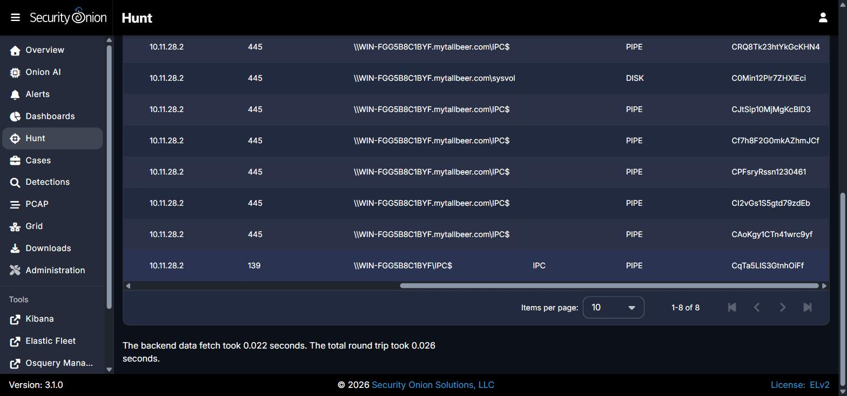
Figure 4 - zeek.smb_mapping records showing smb.path \\WIN-FGG5B8C1BYF.mytallbeer.com\IPC$ and \sysvol - confirms Domain Controller hostname/domain and shares accessed.
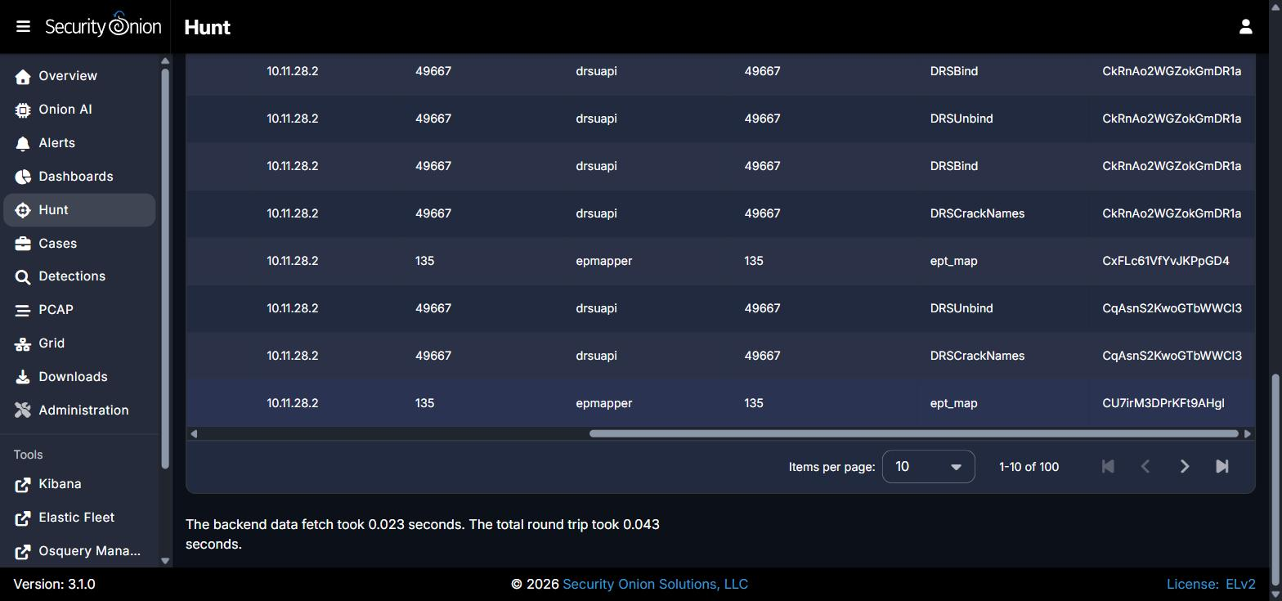
Figure 5 - zeek.dce_rpc records showing drsuapi (DRSBind / DRSCrackNames / DRSUnbind) and epmapper calls from 10.11.28.101 to the Domain Controller.

REPORT QUALITY REQUIREMENTS
5% - 50 Points
- Clear and logical organization
- Correct technical terminology
- Accurate use of timestamps
- Readable screenshots
- Properly labeled tables and figures
- Consistent evidence references
- Clear distinction between confirmed facts and analyst inference
- Professional presentation and readability

SUBMISSION INSTRUCTIONS
1. Submit one report for each phase designated as Report-Required.
2. Submit the final report in PDF format unless otherwise directed.
3. Clearly indicate the team name, phase number, and phase title.
4. Use UTC for timestamps.
5. Major findings must be supported by evidence.
6. Screenshots must be numbered and captioned.
7. Do not include executable malware samples in the report.
8. State 'Not Determined' when a finding cannot be confirmed.
9. Ensure all screenshots, tables, and text are readable.
10. Reports must be submitted before the deadline announced by exercise control.
Evidence Rule: A correct finding without supporting Security Onion, Kibana, Elasticsearch, Zeek, Suricata, or other authorized evidence may receive no more than 50% of the points assigned to that finding. Incorrect or fabricated evidence receives zero points for the affected finding.

